[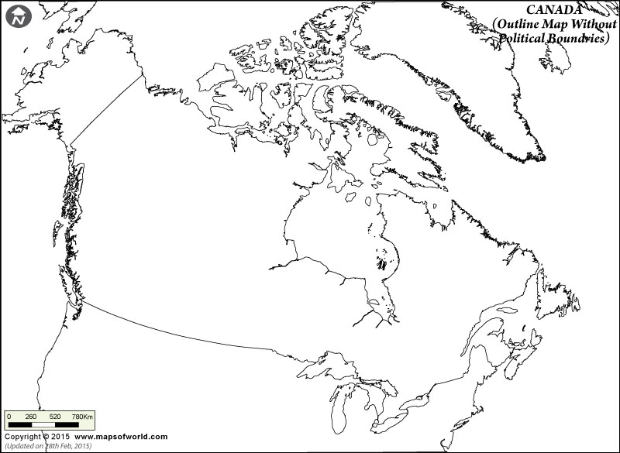](http://www.google.ca/url?sa=i&rct=j&q=&esrc=s&source=images&cd=&cad=rja&uact=8&ved=0ahUKEwjHvbDPmanSAhWp44MKHRTzAGwQjRwIBw&url=http://www.mapsofworld.com/canada/outline-map.html&psig=AFQjCNGKoIFJfyAlbYTe-5GVzIo3Np6O-w&ust=1488041740071804)